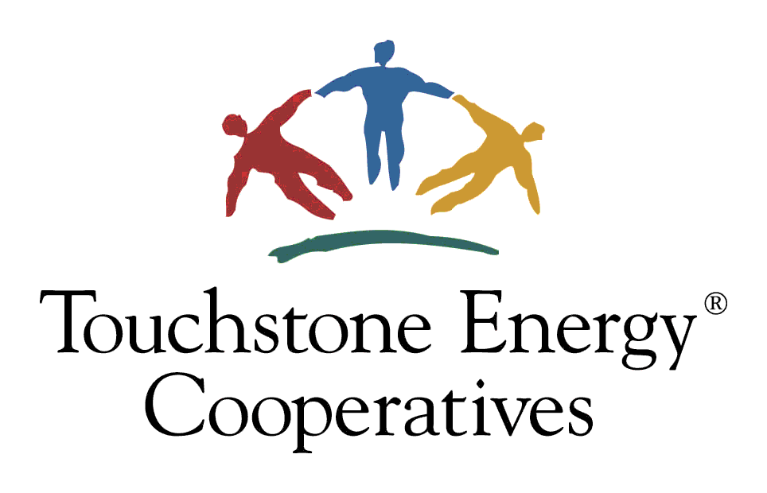 |  |  | Touchstone Energy® Home program  2023 Energy Efficiency Incentive Form  (Dairyland Power Cooperative System Only / Iowa and Illinois New Homes)  This institution is an equal opportunity provider.
ELIGIBILITY CRITERIA
- To qualify for this program’s $500 incentive, ONE of the following three Program/Code requirements must be met:
- Touchstone Energy® Home Program To qualify for the incentive under this Program/Code, the following is required:
- A qualified rater or inspector* must verify ALL the requirements on the attached checklist have been met unless Not Applicable.
- Submit the completed checklist and this incentive form with Section 1 and Section 2 completed.

- Touchstone Energy® Home Program with blower door test in place of Ductwork & Air Infiltration Control requirements To qualify for the incentive under this Program/Code, the following is required:
- A qualified rater or inspector* must verify all requirements on the attached checklist have been met unless Not Applicable, except for the requirements in the Ductwork & Air Infiltration Control category.
- A blower door test is required in place of the Ductwork & Air Infiltration Control requirements. Less than 3 air exchanges/hour at -50 Pascal is considered passing. Person performing the test must complete Section 3 of this incentive form.
- Submit completed checklist and this incentive form with Section 1, Section 2, and Section 3 completed.

- 2012 International Energy Conservation Code To qualify for the incentive under this Program/Code, the following is required:
- A qualified rater or inspector* must provide documentation showing compliance with IECC 2012 using REScheck software.
- A blower door test is required. Less than 3 air exchanges/hour at -50 Pascal is considered passing. Person performing the test must complete Section 3 of this incentive form.
- Submit documentation showing compliance with IECC 2012 and this incentive form with Section 1 and Section 3 completed.

*A qualified rater or inspector refers to a person who is knowledgeable in building standards, has experience in using blower door test equipment, if blower door test is performed, and is approved by your electric cooperative.

- New home or multi-family dwelling must be on cooperative’s lines.
- For multi-family dwellings, each structure may receive only one $500 incentive and the person requesting the incentive must be the owner of the structure and must be a member of the cooperative.
- Incentives are in place through December 31, 2023. Funds are limited so submit required documentation as soon as possible.
- Required documentation must be submitted within 3 months of certification.
- Additional eligibility criteria may apply. Program is subject to change or cancellation without notice. Contact cooperative for details.
- Required documentation listed below must be submitted no later than 3 months after certification.
    - This incentive form
    - Documentation as explained above, depending on which Program/Code was followed
Submit required documentation to: Allamakee-Clayton Electric Cooperative
PO Box 715
Postville, IA 52162-0715 | email: rwagner@acrec.coop

Section 1: MEMBER INOFRMATION (Please fill out entire section)
Member Name |  |  | Email  Email addresses will be used for cooperative communication only.
Address |  |  | Account | Phone
City | State | Zip | Date | Member Signature
Which Program/Code requirement has been met to qualify you for this incentive (Program/Code requirements are listed above)?
Touchstone Energy® Home Program Touchstone Energy® Home Program with Ductwork & Air Infiltration Control requirements bypassed
2012 International Energy Conservation Code
Section 2: RATER / INSPECTOR VERIFICATION (Please fill out entire section if home satisfies requirements of Program/Code 1 or Program/Code 2 as defined under ELIGIBILITY CRITERIA above)
By signing this form, the rater or inspector certifies that the home has met:
- All requirements in the attached checklist, unless Not Applicable, if member is qualifying with option 1 (Touchstone Energy® Home Program) OR
- All requirements in the attached checklist, unless Not Applicable, if member is qualifying with option 2 (Touchstone Energy® Home Program less the Ductwork & Air Infiltration Control requirements). NOTE: Ductwork & Air Infiltration Control requirements can be marked Not Applicable as a blower door test is being done instead.
Rater or Inspector Name |  | Rater or Inspector Signature |  | Date of Final Inspection
Section 3: BLOWER DOOR TEST VERIFICATION (Please fill out entire section if home satisfies requirements of Program/Code 2 or Program/Code 3 as defined under ELIGIBILITY CRITERIA above)
By signing this form, the person performing the blower door test certifies that the home has met the requirement of less than 3 air exchanges per hour at -50 Pascal. |  |  |  | Air Exchanges Per Hour
Name of Person Performing Blower Door Test |  | Signature of Person Performing Blower Door Test |  | Date of Blower Door Test
OFFICE USE ONLY
Approved Not Approved-Reason: |  |  |  | Total Incentive Issued: $
Cooperative Representative: |  |  |  | Date:

